# Chapter 6 : Manager Manual

# 6.1. Home Page

# Home Page 2.png

# 6.2. Admin Guidelines

# Login

Step 1 : Click “Đăng nhập” on header in Home Page. System will display the Login page.

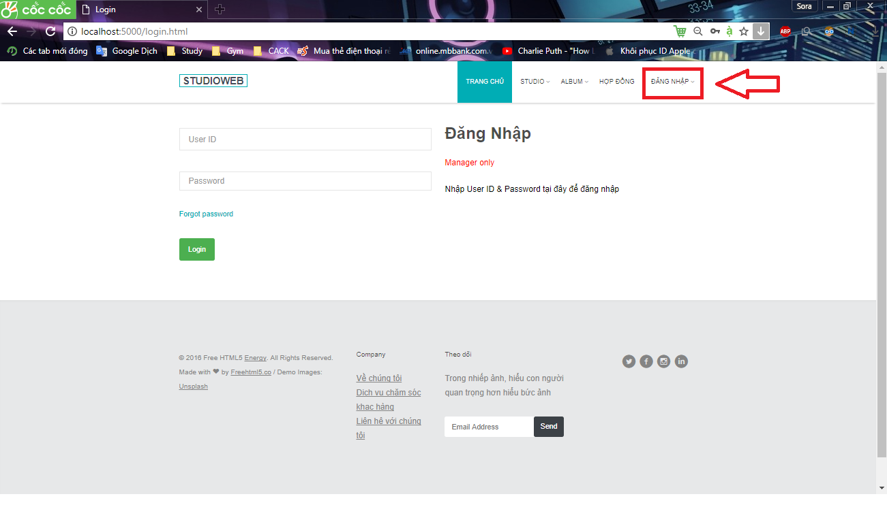

Step 2 : Enter login credentials and click "Đăng nhập" to log in.

## Log out

Click "Đăng xuất" in the top right corner.

**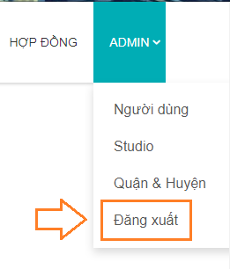**

## Admin Manager

After login successfully with admin account admin manager page will be display

**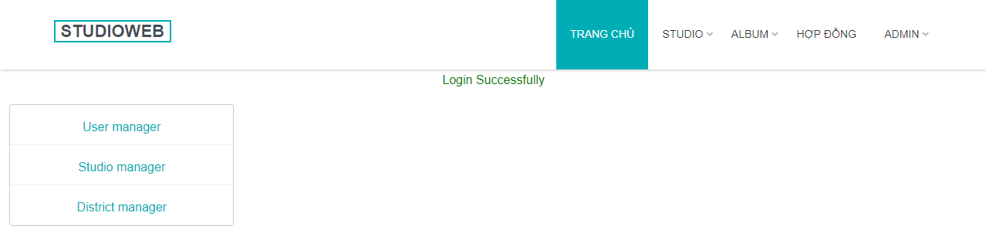**

3.1 **List Manager**

Click on “Quản lý nhân viên” link to open List Manager page.

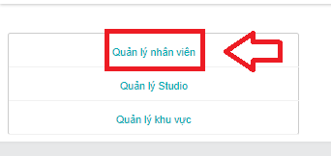

#### Search Manager

Option 1 :

Click on “Hiển thị tất cả” link to display all Manager.

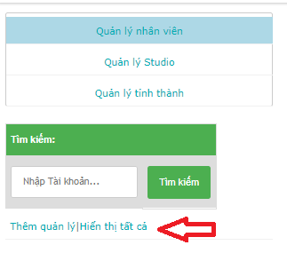

Option 2 :

Step 1 : Empty Search field.

Step 2 : Click on “ Tìm Kiếm ” button. All Manager will be display.

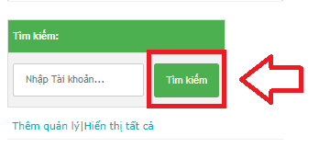

Option 3 :

Step 1 : Enter correct “ Tài khoản ” or a part of “ Tài khoản ” in Search text field.

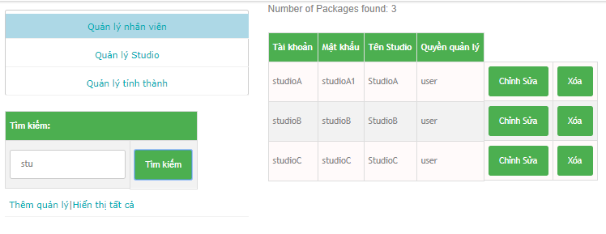

Step 2 : Click on Search button. All Manager have “ Tài Khoản ” like search value will be display.

2. Edit Manager

Step 1 : Click on “ Chỉnh sửa ” button. “ Chỉnh sửa quản lý ” form will be display.

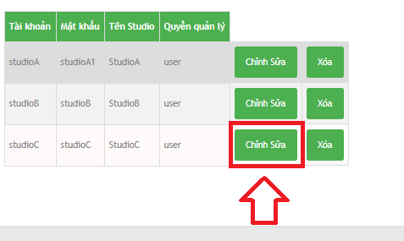

Step 2 : Enter new Password on “ Mật khẩu ” field.

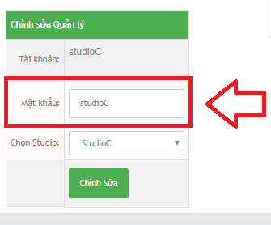

* New Password rules :
  + In range 6 ~ 32 character.
  + Not empty.
  + Can contain special character (!@#$%^&\*)

Step 3 : Select Studio.

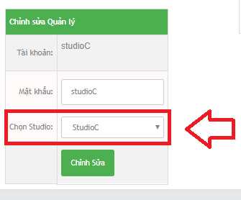

Step 4 : Click “ Chỉnh sửa ” button.

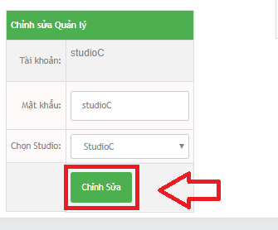

3. Delete Manager

Step 1 : Click on “ Xóa ” button.

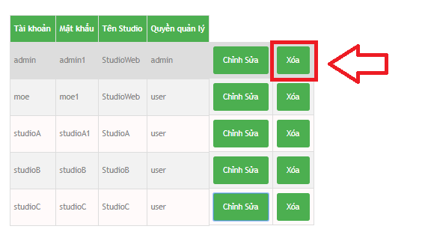

Step 2 : Click on OK button on confirm window.

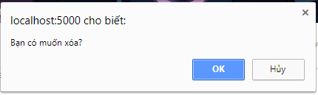

4. Add Manager

Click on “ Thêm quản lý ” link to open “ Thêm người quản lý ” form.

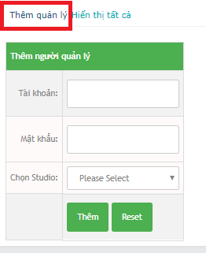

Step 1 : Enter new Manager Account on “ Tài khoản ” field.

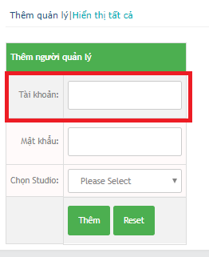

* New Manager Account rules :
  + Not special character.
  + Not empty.
  + In range 6 ~ 32 character.

Step 2 : Enter new Password on “ Mật khẩu ” field.

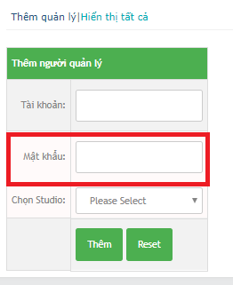

* New Password rules :
  + In range 6 ~ 32 character.
  + Not empty.
  + Can contain special character (!@#$%^&\*).

Step 3 : Select Studio.

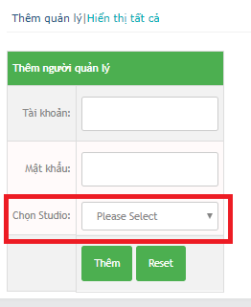

Step 4 : Click “ Thêm ” button.

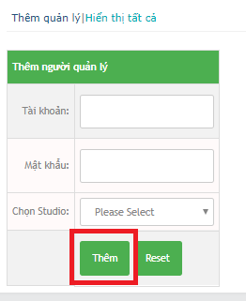

Reset button to clear all field.

3.2. Studio Manager.

Click on “ Quản lý Studio ” link to open Studio Manager form.

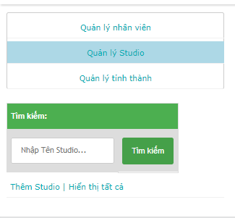

#### Search Studio

Option 1 :

Click “ Hiển thị tất cả “ link to display all Studio.

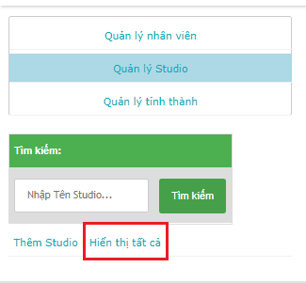

Option 2 :

Step 1 : Empty Search field.

Step 2 : Click on “ Tìm kiếm ” button. All Studio will be display

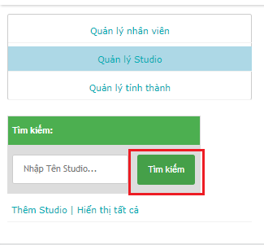

Option 3 :

Step 1 : Enter correct or a part of “ Tên Studio ”.

Step 2 : Click on “ Tìm kiếm ” button. All Studio have “ Tên Studio ” like search value will be display.

#### Show Studio location

Click on “ Tọa độ Studio ” link to open Studio location on Google Map page.

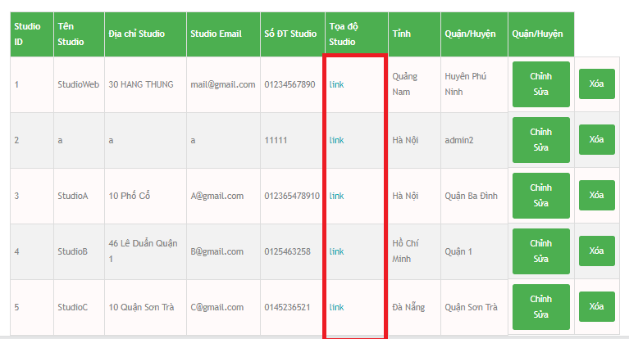

#### Edit Studio

Step 1 : Click on “ Chỉnh sửa ” button to open “ Chỉnh sửa Studio ” form.

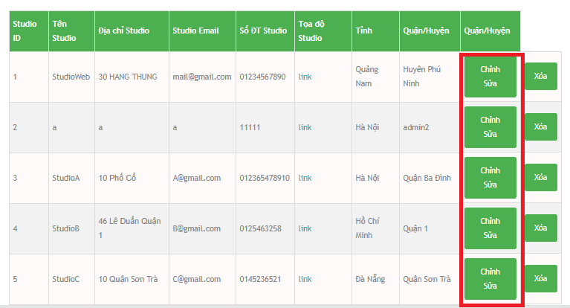

Step 2 : Enter new Studio Name on “ Tên Studio ” field.

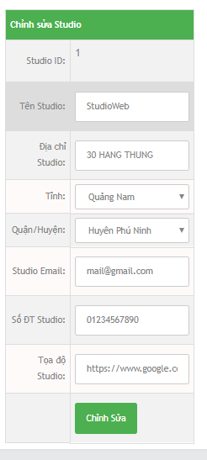

* New Studio Name rules :
  + Not special character.
  + Not empty.
  + In range 6 ~ 32 character.

Step 3 : Enter new Studio Adress on “ Địa chỉ Studio ” field.

* New Studio Adress rules :
  + Not empty.
  + In range 6 ~ 32 character.

Step 4 : Select “ Tỉnh ”.

Step 5 : Select “ Quận / Huyện ”.

Step 6 : Enter new Studio Email on Studio Email field.

* New Studio Email rules :
  + Correct form.(abc@abc.abc)
  + Not empty.
  + Just allow "@","." character.
  + In range 6 ~ 32 character.

Step 7 : Enter new Studio Number on “ Số ĐT Studio” filed.

* New Studio Number rules :
  + Must be number.
  + Not empty.
  + In range 10 ~ 12 character.

Step 8 : Enter new Studio Coordinate on “ Tọa độ Studio ” field.

* New Studio Coordinate rules :
  + Not empty.
  + Correct form. (Float number , Float number).

Step 9 : Click on “ Chỉnh Sửa ” button.

#### Delete Studio.

Step 1 : Click on “ Xóa “ button.

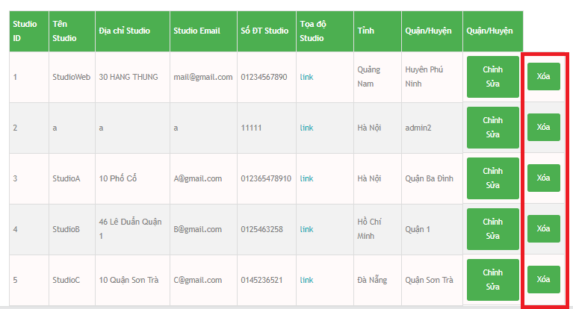

Step 2 : Click OK button on confirm window.

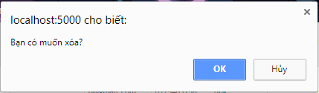

#### Add Studio

Step 1 : Click on “ Thêm Studio ” link to open “Thêm Studio mới ” form.

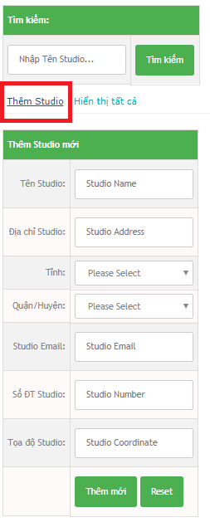

Step 2 : Enter Studio Name on “ Tên Studio” field.

* Studio Name rules :
  + Not special character.
  + Not empty.
  + In range 6 ~ 32 character.

Step 3 : Enter Studio Adress on “ Địa chỉ Studio ” field.

* Studio Adress rules :
  + Not empty.
  + In range 6 ~ 32 character.

Step 4 : Select “ Tỉnh ”.

Step 5 : Select “ Quận / Huyện ”.

Step 6 : Enter Studio Mail on Studio Email field.

* Studio Email rules :
  + Correct form.(abc@abc.abc)
  + Not empty.
  + Just allow "@","." character.
  + In range 6 ~ 32 character.

Step 7 : Enter Studio Number on “ Số ĐT Studio ” field.

* Studio Number rules :
  + Must be number.
  + Not empty.
  + In range 10 ~ 12 character.

Step 8 : Enter Studio Coordinate on “ Tọa độ Studio ” field.

* Studio Coordinate rules :
  + Not empty.
  + Correct form. (Float number , Float number).

Step 9 : Click on “ Thêm mới ” button.

Reset button to clear all text field.

### 3.3. District Manager

### Click on “ Quản lí tỉnh thành ” link to display District manager form.

### 

#### Search District

Step 1 : Select “ Tỉnh / Thành phố ”.

Step 2 : Click “ Tìm kiếm ” button.

#### Add new District

Step 1 : Choose “ Tỉnh / Thành Phố ”.

Step 2 : Enter new District on “ Nhập Quận / Huyện ” field.

* New Dictrict rules :
  + Not special character.
  + Not empty.
  + In range 6 ~ 32 character.

Step 3 : Click “ Thêm mới ” button.

# 6.3. Manager Guidelines.

# Login

Step 1 : Click “Đăng nhập” on header in Home Page. System will display the Login page.



Step 2 : Enter login credentials and click "Đăng nhập" to log in.

# After login Manager page will be display.

# 

## Logout

Click "Đăng xuất" in the top right corner.

# Logout manager.png

## Studio Profile

Click on “ Thông tin Studio ” link to display Studio Profile form.

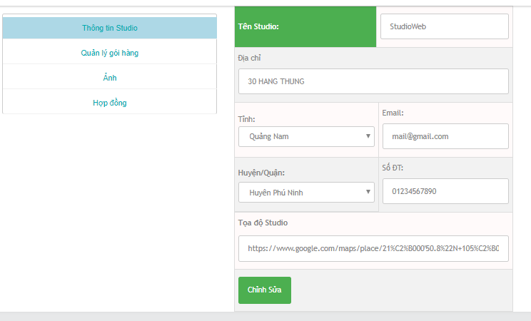

### Edit Studio Profile

### Step 1 : Edit field want to edit.

### Step 2 : Click on “ Chỉnh sửa ” button.

## Package Manager

Click “ Quản lí gói hàng ” link to display Package Manager form.

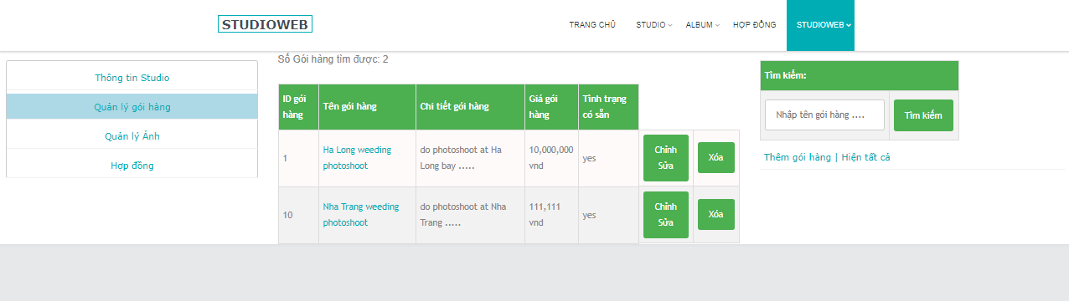

### Search Package

### Option 1 :

### Click on “ Hiển thị tất cả “ link to display all package.

### Option 2 :

### Step 1 : Empty Search field.

### Step 2 : Click Search button. All package will be display.

### Option 3 :

### Step 1 : Enter correct or a part of Package Name to search field.

### Step 2 : Click Search button, All package have package name like search value will be display.

### Edit Package

### Step 1 : Click on Edit button to display Edit Package form.

### Zalo_ScreenShot_20_4_2018_1715111.png

### Step 2 : Enter new Package Name.

* New Package Name rules :
  + Not special character.
  + Not empty.
  + In range 6 ~ 32 character.

Step 3 : Enter new Package Detail.

* New Package Detail rules :
  + Not empty.

Step 4 : Enter new Package Price.

* New Package Price rules :
  + Must be number bigger than 0.

Step 5 : Select Package Avalability.

Step 6 : Click Edit button.

Reset button to clear all field.

### Delete Package.

### Step 1 : Click on “ Xóa “ button.

### a.png

### Step 2 : Click OK button on confirm window.

### 

## Picture Manager

Click on “ Quản lý ảnh ” link to display Picture Manager.

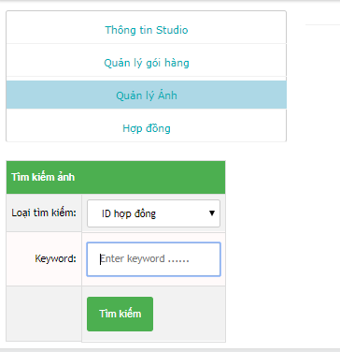

### Search Contract Detail by keyword

### Option 1 :

### Step 1 : Select Search Type is “ ID hợp đồng ”.

### Step 2 : Enter correct ContractID on keyword field.

### Step 3 : Click on “ Tìm kiếm ” button.

### 

### Option 2 :

### Step 1 : Select SearchType is “ Tên khách hàng ”.

### Step 2 : Enter correct or a part of Customer Name on keyword field.

### Step 3 : Click on “ Tìm kiếm ” button.

### View Picture

### Click on “ Xem ảnh ” button to open Picture Detail page.

### a.png

#### Search Picture

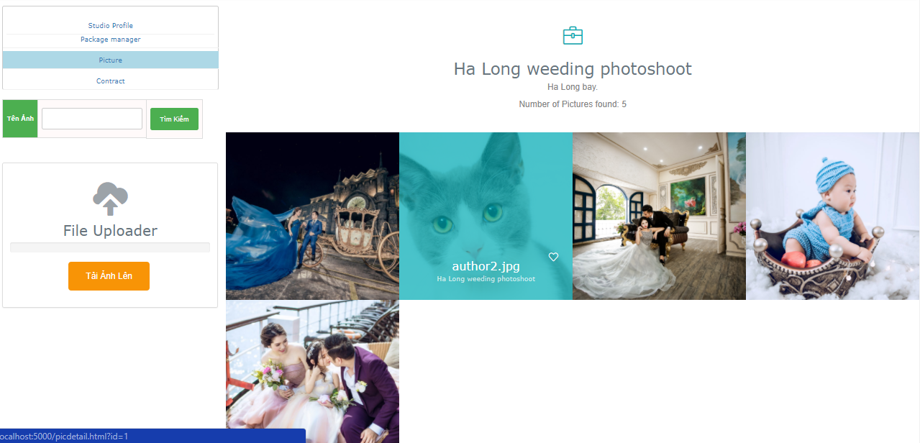

**Step 1 : Enter correct or a part of Picture Name on “ Tên Ảnh ” field.**

**Step 2 : Click “ Tìm Kiếm ” button.**

#### Upload Picture

Step 1 : Click on “ Tải Ảnh Lên ” button.

Step 2 : Choose picture file on computer.

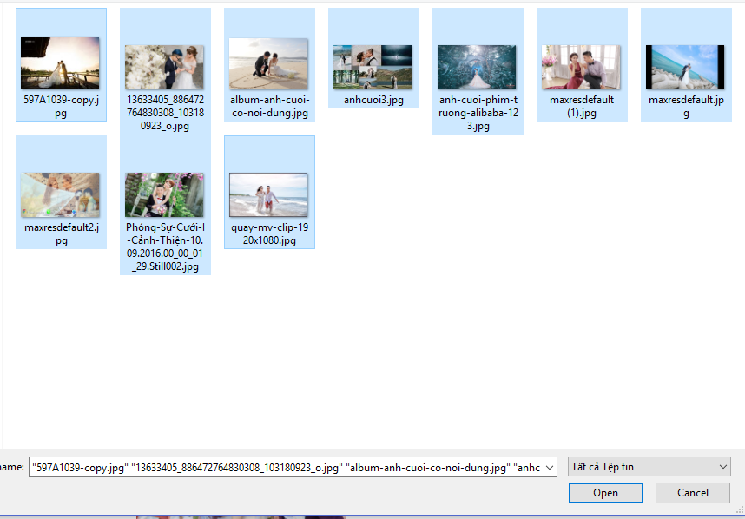

Step 3 : Click Open button.

#### Update Picture Detail

Step 1 : Click on Picture want to update to open Picture Detail form.

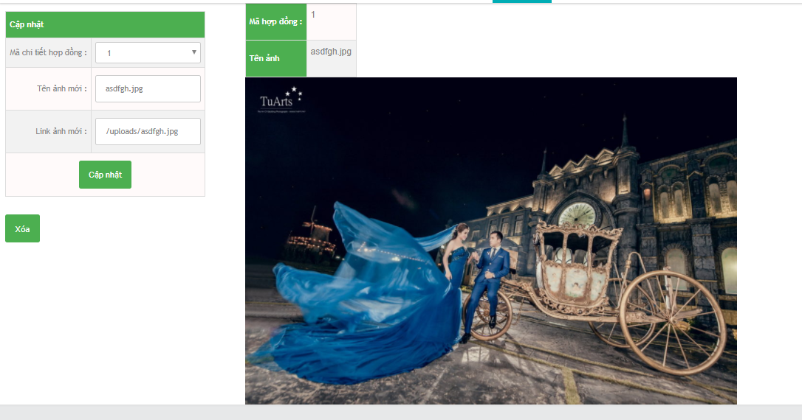

Step 2 : Select “ Mã chi tiết hợp đồng ”.

Step 3 : Enter new Picture Name on “ Tên ảnh mới ” field.

Step 4 : Enter new Picture URL on “ Link ảnh mới ” field.

Step 5 : Click “ Cập nhật ” button.

#### Delete Picture.

Step 1 : Click on Picture want to delete to open Picture Detail form.

Step 2 : Click on “ Xóa “ button.

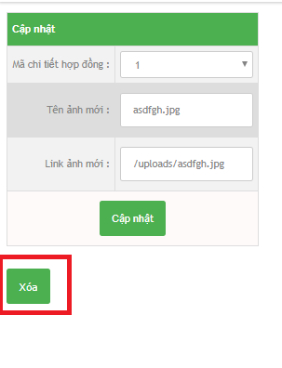

Step 3 : Click on OK button on confirm window.



## Contract Manager

Click on “Hợp đồng ” link to open Contract Manager page.

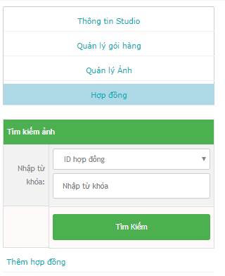

### Search Contract

### Option 1 :

### Step 1 : Empty keyword field.

### Step 2 : Click on “ Tìm kiếm ” button. All Contract will be display.

### Option 2 :

### Step 1 : Select Seach type is “ ID hợp đồng ”.

### Step 2 : Enter correct Contract ID in “ Nhập từ khóa ” field.

### Step 3 : Click on “ Tìm kiếm ” button. All Contract have Contract ID equal Search value will be display.

### Option 3 :

### Step 1 : Select Search type is “ Tên khách hàng ”.

### 

### Step 2 : Enter correct or a part of exsit Customer Name on “ Nhập từ khóa ” field.

### Step 3 : Click “ Tìm kiếm ” button. All Contract have Customer Name like Search value will be display.

### Option 4 :

### Step 1 : Select Search type is “ Số ĐT khách hàng ”.

### 

### Step 2 : Enter correct or a part of exsit Customer Phone on “ Nhập từ khóa ” field.

### Step 3 : Click “ Tìm kiếm ” button. All Contract have Customer Phone like keyword value will be display.

### Edit Contract.

### Step 1 : Click on “ Sửa ” button to display Edit Contract form.

### Zalo_ScreenShot_21_4_2018_243703.png

### Step 2 : Select “Tình trạng hợp đồng”.

### 

### Step 3 : Edit field want to edit.

* Edit Contract rules :
  + Customer Name :
  + Not empty.
  + Not special character.
  + In range 6 ~ 32 character.
  + Not number.
* Adress :
* Not empty.
* In range 6 ~ 32 character

### Gender :

### Just select only one

### Phone :

### Not empty.

### Must be number.

### In range 10 ~ 12 character.

### Email :

### Must be correct form.

### Not empty,

### Just allow '@','.' character.

### In range 6 ~ 32 character.

### Studio wolking :

### Must choose

### Name of product:

### Must choose

### Package detail :

### Not empty

### Contract detail :

### Not empty

### Create date :

### Must choose.

### Must smaller or equal with Start date and End Date.

### Start date :

### Must choose.

### Must smaler or equal with End date.

### End Date :

### Must choose bigger or equal with Create date and Start Date.

### Step 4 : Click on “ Nhập ” button.

### Add Contract

### Step 1 : Click on “ Thêm hợp đồng ” link to display Add Contract form.

### Step 2 : Select Contract status.

### Step 3 : Enter Customer Name

* + Customer Name rules :
  + Not empty.
  + Not special character.
  + In range 6 ~ 32 character.
  + Not number.

### Step 4 : If Customer is old Customer click on checkbox “ Khách hàng cũ? ” to skip enter Adress, Gender, Email, Note.

### Step 5 : Enter Customer Adress on “ Địa chỉ khách hàng ” field.

* Adress rules :
* Not empty.
* In range 6 ~ 32 character

### Step 6 : Select Gender

### Step 7 : Enter Customer Phone on “ Số điện thoại ” field.

### Phone rules :

### Not empty.

### Must be number.

### Step 8 : Enter Customer Email on Email field.

### Email rules :

### Must be correct form.

### Not empty,

### Just allow '@','.' character.

### In range 6 ~ 32 character.

### Step 9 : Enter Note or not on “ Ghi chú về khách hàng ” field.

### Step 10 : Select Package on “ Tên sản phẩm ” dropdown list.

### If Customer buy more than one Package. Click “ Nhập thêm ” button to add more package.

### Step 11 : Enter Note or not on “ Ghi chú : ” field.

### Step 12 : Enter Contract Detail on “ Chi tiết hợp đồng ” field.

### Step 13 : Select “ Ngày lập nên hợp đồng ”

### Step 14 : Select “ Ngày bắt đầu làm việc ”

### Step 15 : Select “ Ngày kết thúc ( theo dự đoán ) ”

### Step 16 : Click “ Nhập ”

### View Contract Detail

### Click on “ID Hợp đồng” link to open Contract Detail page.

#### Edit Contract Detail.

Step 1 : Click on “ Sửa ” button.

Step 2 : Edit field want to edit.

Step 3 : Click “ Chỉnh sửa ” button.

#### Delete Contract Detail.

Step 1 : Click on “ Xóa ” button.

Step 2 : Click OK button on confirm window.

#### View Picture form Contract Detail.

Click on “ Xem ảnh ” button to open Picture Detail Page.

#### Add new Picture Detail.

Step 1 : Click on “ Thêm mới chi tiết hợp đồng ” link to display Add new Picture Detail form.

Step 2 : Enter Package Name on “ Tên gói hàng ” field.

* Package Name rules :
  + Not special character.
  + Not empty.
  + In range 6 ~ 32 character.

Step 3 : Enter Package Detail on “ Chi tiết gói hàng ” field.

* Package Detail rules :
  + Not empty.

Step 4 : Enter Package Price on “ Giá gói hàng ” field.

* Package Price rules :
  + Must be number bigger than 0.

Step 5 : Enter Not or not on “ Ghi chú ” field.

Step 6 : Click on “ Thêm mới ” button.

# Customer Guidelines.

## Open Home Page

Option 1 : Click on StudioWeb logo on header.

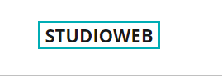

Option 2 : Click on “ Trang Chủ ” button on header.

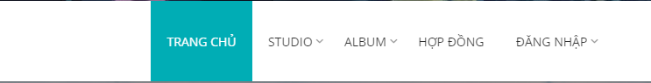

## View Studio List

Option 1 : Click on Studio button on header.

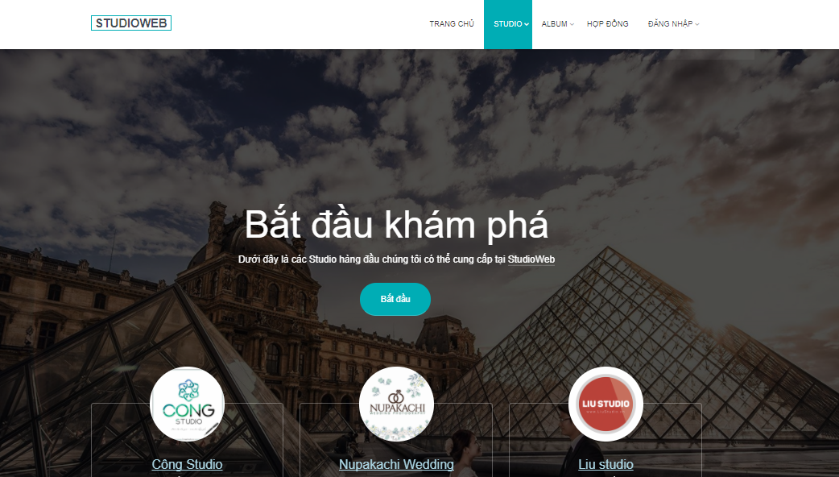

Option 2 : Click one of three “ Bắt đầu ” button on Home Page.



## View Studio Detail Page

Option 1 :

Step 1 : Take the mouse on Studio to open Studio list dropdown list.

Step 2 : Click on Studio want to view.

Option 2 :

Step 1 : Click on Studio button on header to open Studio list page.

Step 2 : Click on Studio Name link to open Studio Detail page.

## View Package Detail

Step 1 : On Studio Detail page. Scroll page to view list of Package.

Step 2 : Click on “ Xem thêm ” button to open Package Detail page.

## Add Package on Cart.

Step 1 : On Package list in Studio Detail. Click on Cart icon of Package want to buy.

Step 2 : Click on Open Cart button Cart Detail page.

Step 3 : Enter Name on “ Tên khách hàng ” field.

Step 4 : Select Gender.

Step 5 : Enter Phone Number on “ Số ĐT khách hàng ” field.

Step 6 : Enter Customer Email on Customer Email field.

Step 7 : Enter Customer Facebook link on Customer Facebook field.

Step 8 : Enter Note or not on Note field.

Step 9 : Click Buy button.

## View review Album.

Click on Album button on header to display review album on Studio.

#### View one of Album type.

Step 1 : Take the mouse on Album button in header.

Step 2 : Click one of Album type in Album list dropdown list.

## Show own Contract.

Step 1 : Click on Contract button on header.

Step 2 : Enter Contract code to display Customer contract.

## Show About Us.

Click “ Về chúng tôi ” link on footer to open About us page.